# **Machine Learning Practical File**

**Name – Neha Dhiman**

**College Rollno.- 2019328**

**Semester:-Vl**

**Subject:-Machine Learning**

**Course - B.Sc. (Hons.) Computer Science**

**Examination Rollno. – 19066570026**

**Q1.Perform elementary mathematical operations in Python like addition, multiplication, division and exponentiation.**

**Program:**

x=int(input("Enter number 1: "))

y=int(input("Enter number 2: "))

print("Results after elementary maths operations:------")

print("Addition: ",x+y)

print("Subtraction: ",x-y)

if(y!=0):

print("Division: ",x/y)

else:

print("Division not possible!!")

print("Multiplication: ",x*y)

print("Exponent: ",x**y)

**Output:-**

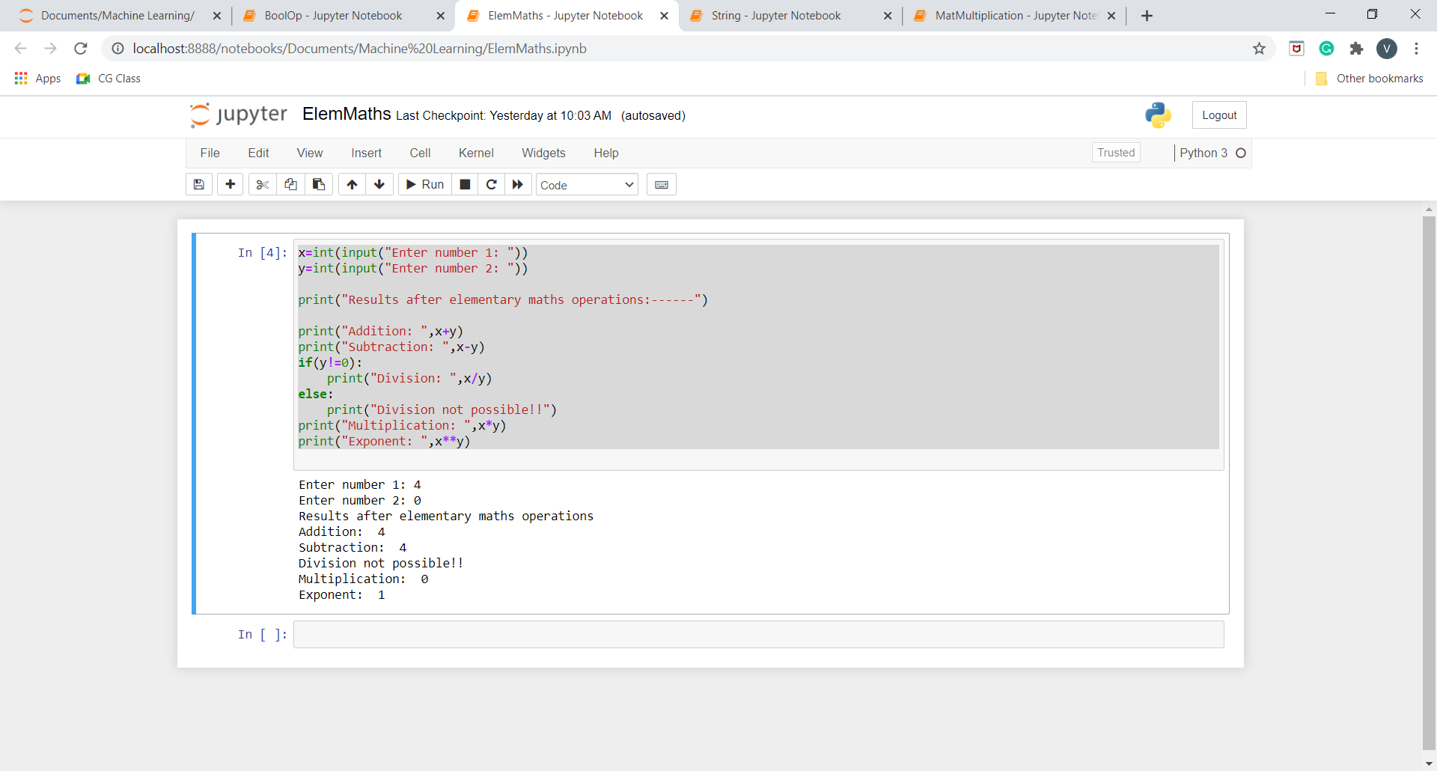

**Q2.Perform elementary logical operations in Python (like OR, AND, Checking for Equality, NOT, XOR).**

**Program:**

x=int(input("Enter number 1: "))

y=int(input("Enter number 2: "))

print("Results after boolean operations:------")

print("AND :",x and y)

print("OR :",x or y)

print("Checking Equality :",x==y)

print("NOT of number 1 :",not x)

print("NOT of number 2 :",not y)

print("XOR :",x^y)

**Output:**

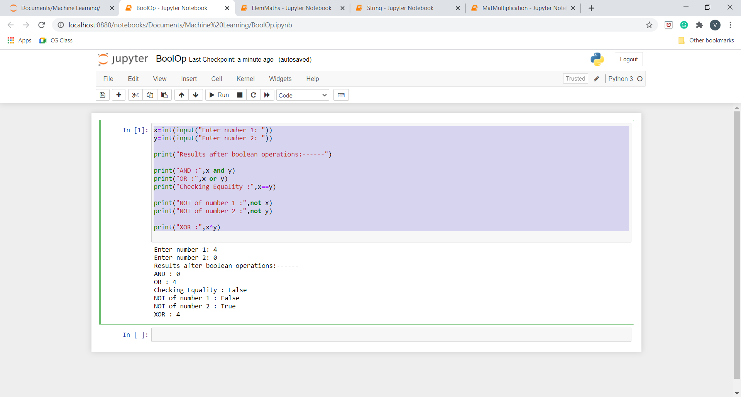

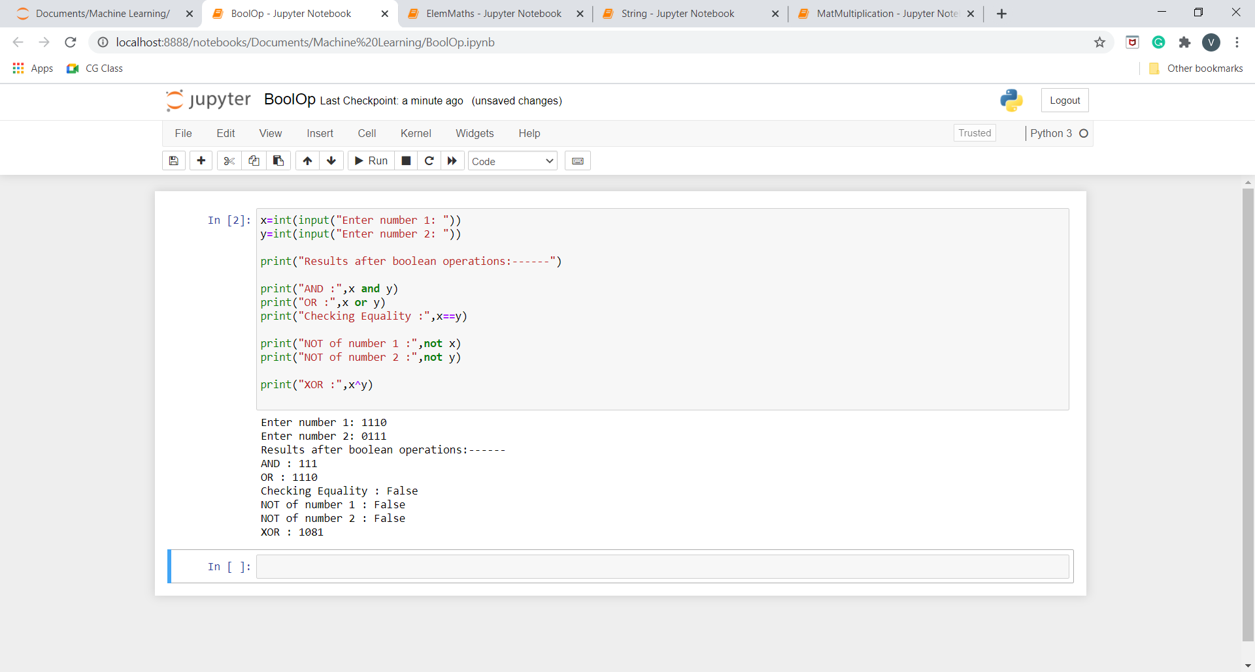

**Q3.Create, initialize and display simple variables and simple strings and use simple formatting for variable.**

**Program:**

x= 2/3

z=16

y= """ vaishnavi jha is great.

Hail mogambo"""

print("String Formatting---------------------")

print(x)

print(y.split())

print(y.splitlines())

print(y.strip())

print(y.upper())

print(y.lower())

print(y.capitalize())

print(y.title())

print("_".join(y.split()))

print()

print("Number Formatting----------------------")

print(int(x))

print("%0.3f"%(x))

print(hex(z))

print(bin(z))

print(oct(z))

**Output:**

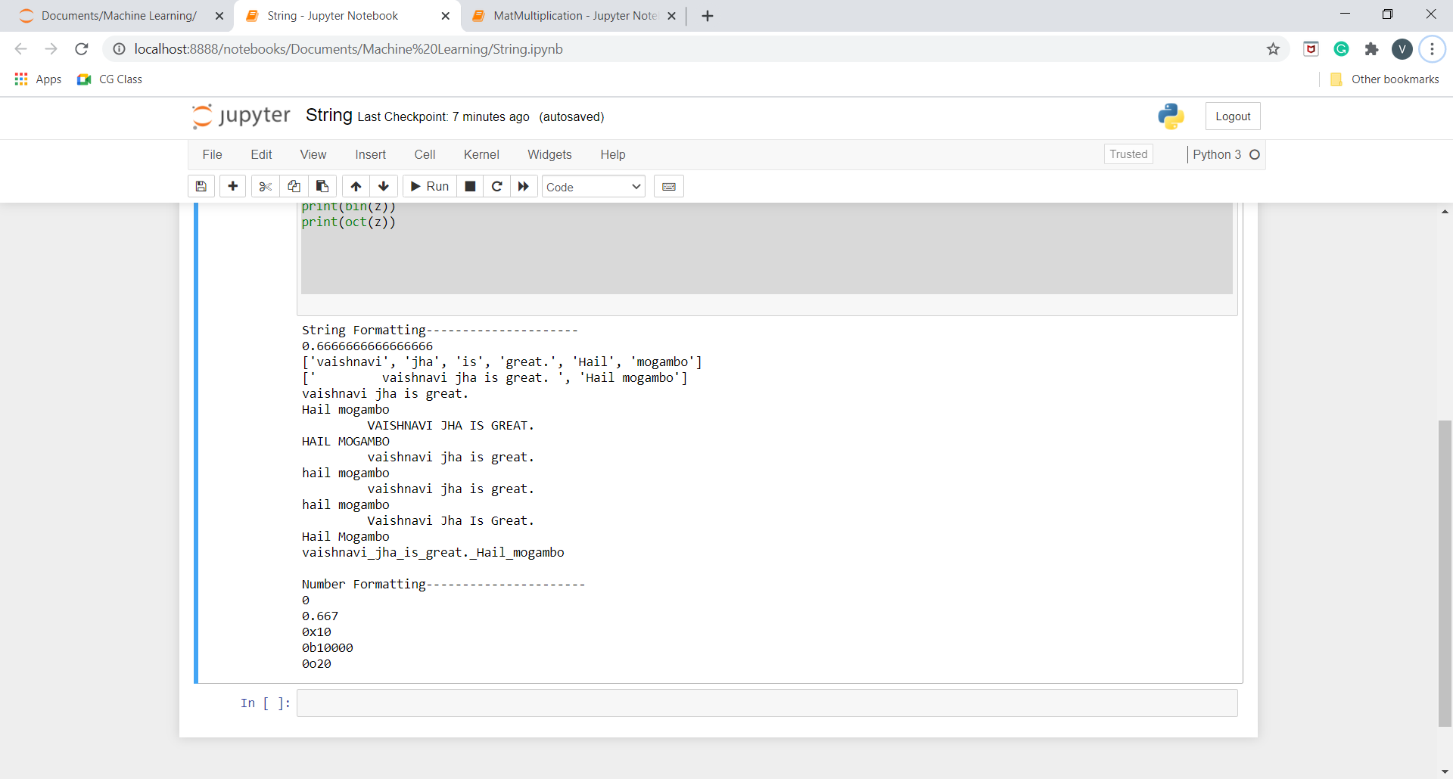

**Q4.Create/Define single dimension / multi-dimension arrays, and arrays with specific values like array of all ones, all zeros, array with random values within a range, or a diagonal matrix.**

**Program:**

import numpy as np

print('Single Dimensional Array :')

print('---------------------------------------------------------------------------')

print('With all zeroes')

print(np.zeros(5,int))

print()

print('With all ones')

print(np.ones(5,int))

print()

print('With all random integers')

print(np.random.randint(1,10,5))

print()

print('With values within a range')

print(np.arange(1,10))

print()

print('Multi Dimensional Array :')

print('---------------------------------------------------------------------------')

print('With all zeroes')

print(np.zeros((4,3),int))

print()

print('With all ones')

print(np.ones((4,3),int))

print()

print('With all random integers')

print(np.random.randint(1,10,(4,3)))

print()

print('With values within a range')

print(np.arange(1,10).reshape(3,3))

print()

print('With diagonal element')

print(np.eye(4,None,0,int))

print()

**Output:**

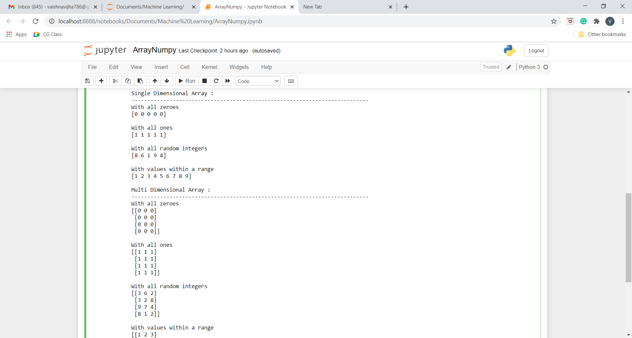

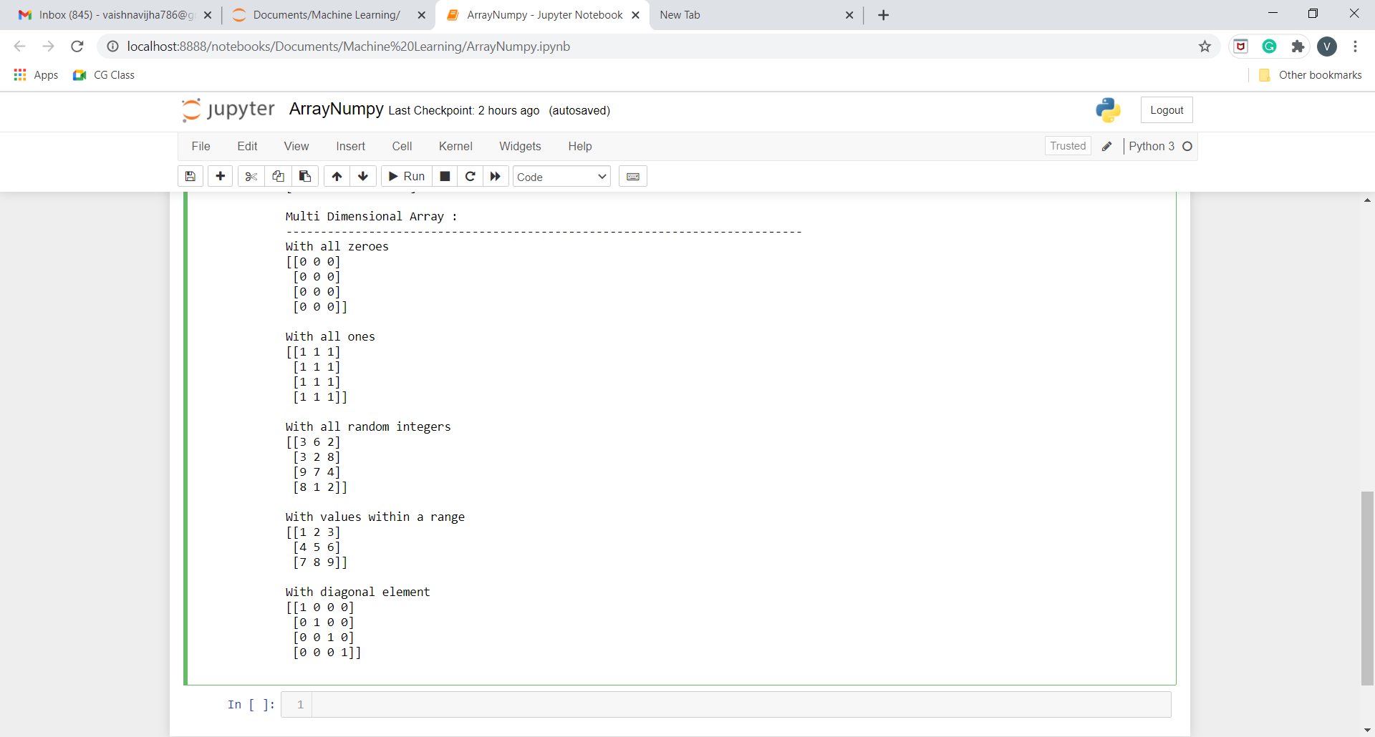

**Q5.Use command to compute the size of a matrix, size/length of a particular row/column, load data from a text file, store matrix data to a text file, finding out variables and their features in the current scope.**

**Program:**

import numpy as np

arr=np.random.randn(4,3)

print('Array:')

print('---------------------------------------------------------------------------')

print(arr)

print()

print('Size of Array:')

print('---------------------------------------------------------------------------')

print(arr.size)

print()

print('Size of particular row (row 2):')

print('---------------------------------------------------------------------------')

print(len(arr[:,2]))

print()

print('Size of particular column (column 2):')

print('---------------------------------------------------------------------------')

print(len(arr[2,:]))

print()

print('Taking input from file: ')

print('---------------------------------------------------------------------------')

with open('numpy2text.txt', 'r') as f:

l =np.loadtxt(f)

print(l)

print()

print('Saving Array to a file: ')

print('---------------------------------------------------------------------------')

with open('numpy2output.txt', 'wb') as f:

np.savetxt(f,arr)

**Output:**

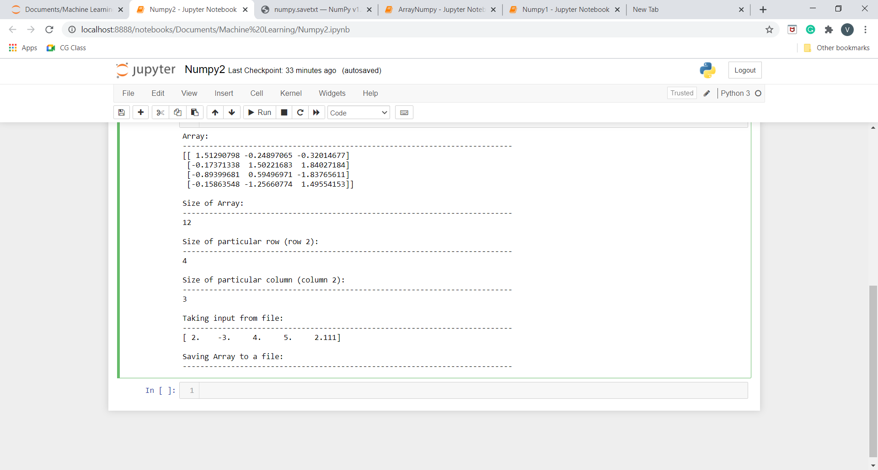

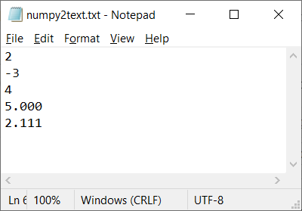

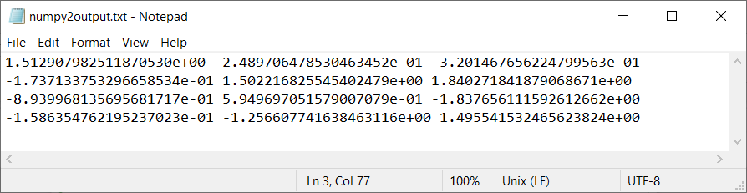

**Q6.Perform basic operations on matrices (like addition, subtraction, multiplication) and display specific rows or columns of the matrix.**

**Program:**

import numpy as np

mat1= np.random.randint(1,10,(3,3))

mat2= np.random.randint(1,10,(3,3))

print("Matrix 1:")

print(mat1)

print("Matrix 2:")

print(mat2)

print()

print('Addition of Two matrices')

print('---------------------------------------------------------------------------')

mat3=mat1+mat2

print(mat3)

print()

print('Subtraction of Two matrices')

print('---------------------------------------------------------------------------')

mat3=mat1+mat2

print(mat3)

print()

print('Multiplication of Two matrices')

print('---------------------------------------------------------------------------')

mat3=mat1*mat2

print(mat3)

print()

mat1= np.random.randint(1,10,(4,3))

mat2= np.random.randint(1,10,(3,2))

print("Matrix 1:")

print(mat1)

print("Matrix 2:")

print(mat2)

print()

print('Element-by-Element Multiplication of Two matrices')

print('---------------------------------------------------------------------------')

mat3=mat1.dot(mat2)

print(mat3)

print()

print('Displaying Specific Rows and column')

print('---------------------------------------------------------------------------')

print(mat3[1:,1:])

**Output:**

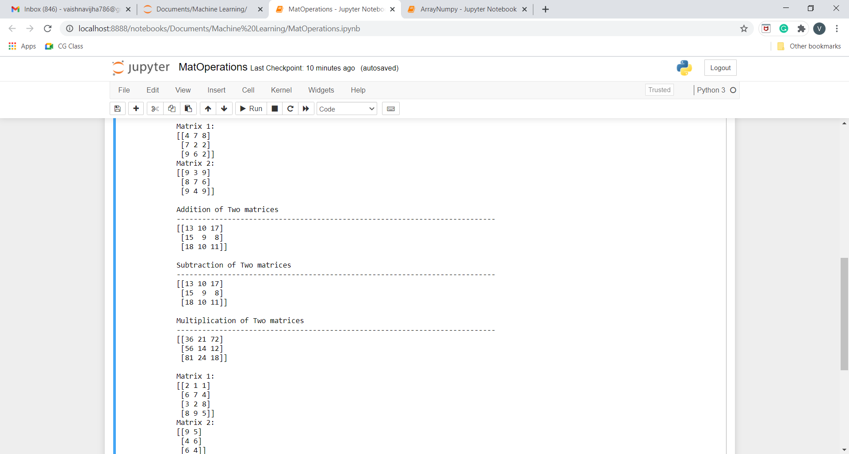

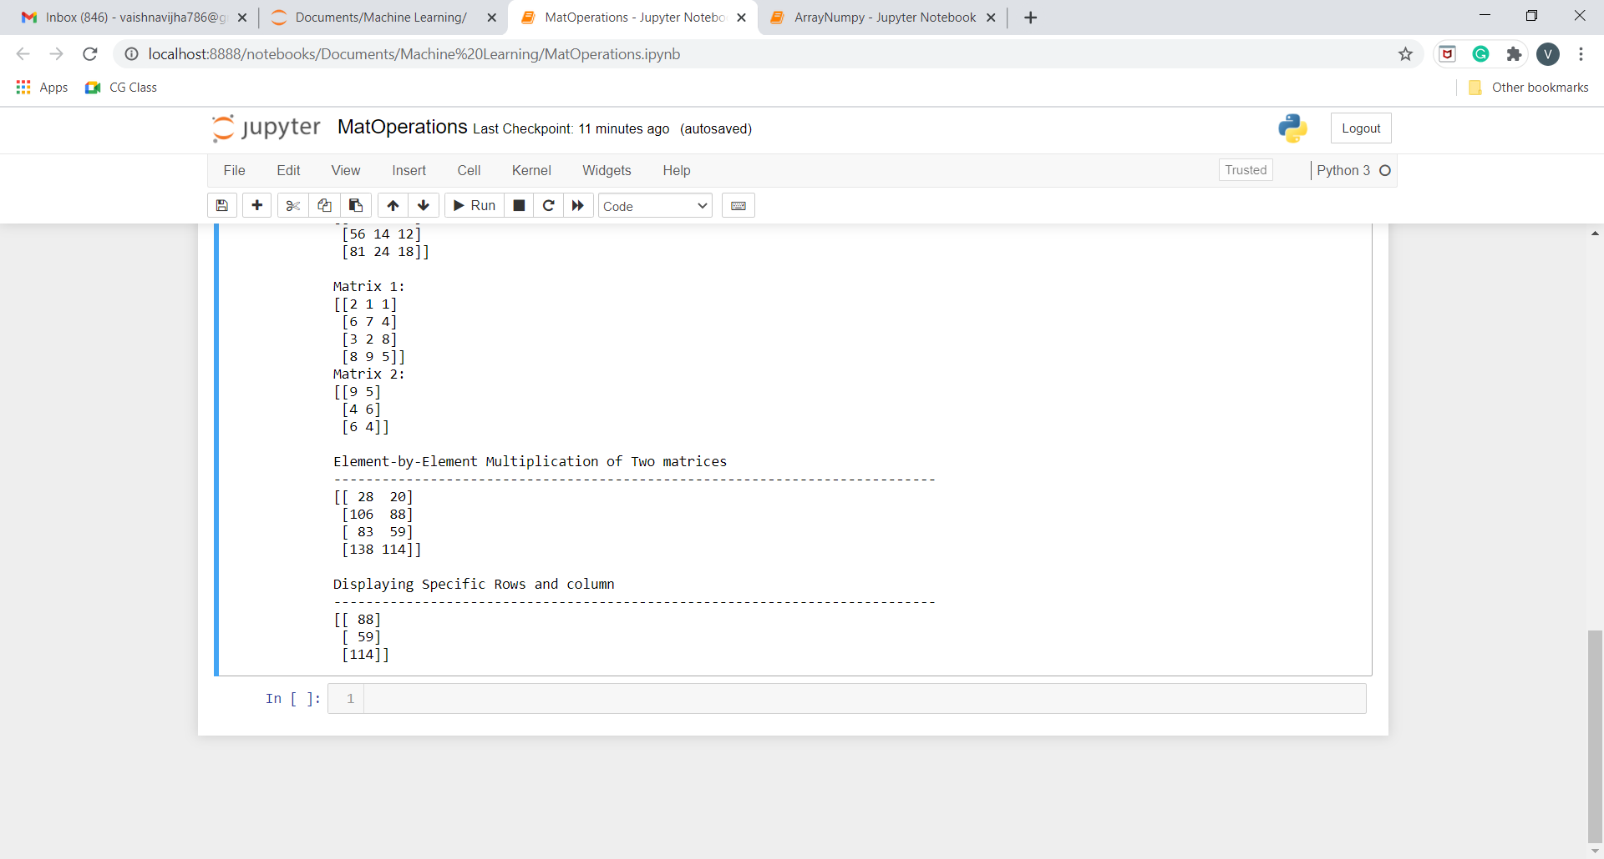

**Q7.Perform other matrix operations like converting matrix data to absolute values, taking the negative of matrix values, additing/removing rows/columns from a matrix, finding the maximum or minimum values in a matrix or in a row/column, and finding the sum of some/all elements in a matrix.**

**Program:**

import numpy as np

arr=np.random.randn(4,3)

print('Array:')

print('---------------------------------------------------------------------------')

print(arr)

print()

print('Absolute Value of the Array')

print('---------------------------------------------------------------------------')

print(np.absolute(arr))

print()

print('Negative Value of the Array')

print('---------------------------------------------------------------------------')

print(np.negative(arr))

print()

print('Array after deleting row 2')

print('---------------------------------------------------------------------------')

print(np.delete(arr,2,0))

print()

print('Array after deleting column 2')

print('---------------------------------------------------------------------------')

print(np.delete(arr,2,1))

print()

print('Maximum of Array')

print('---------------------------------------------------------------------------')

print(np.max(arr))

print()

print('Minimum of Array')

print('---------------------------------------------------------------------------')

print(np.min(arr))

print()

print('Sum of all elements of Array')

print('---------------------------------------------------------------------------')

print(np.sum(arr))

print()

print('Sum of all elements of Array row-wise')

print('---------------------------------------------------------------------------')

print(np.sum(arr,0))

print()

print('Sum of all elements of Array column-wise')

print('---------------------------------------------------------------------------')

print(np.sum(arr,1))  
  
**Output:**

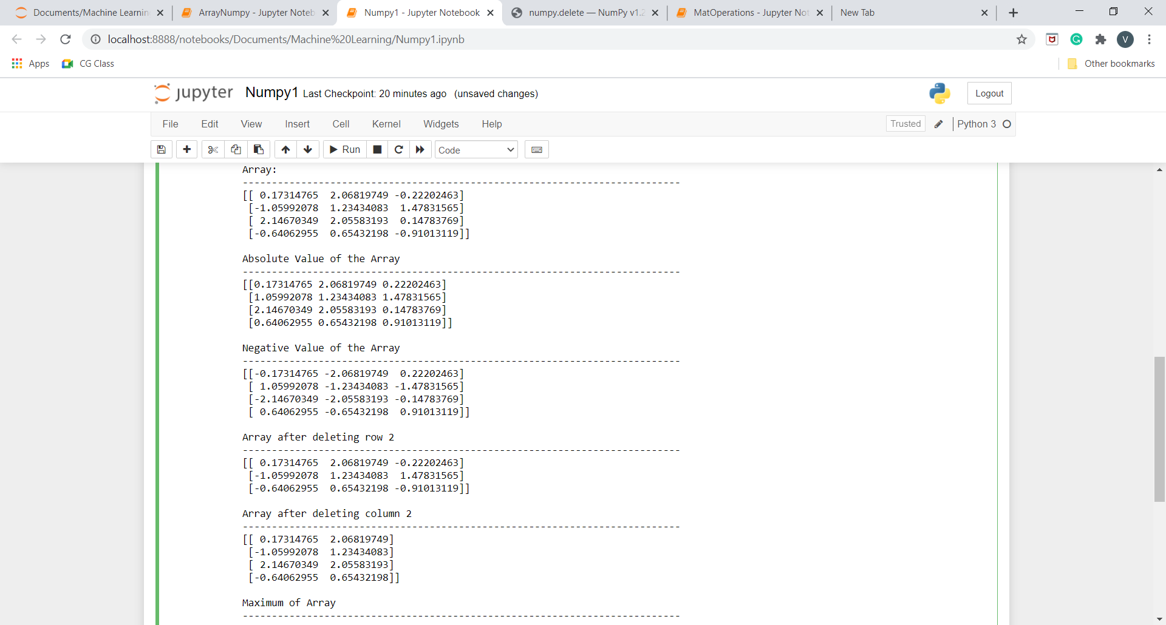

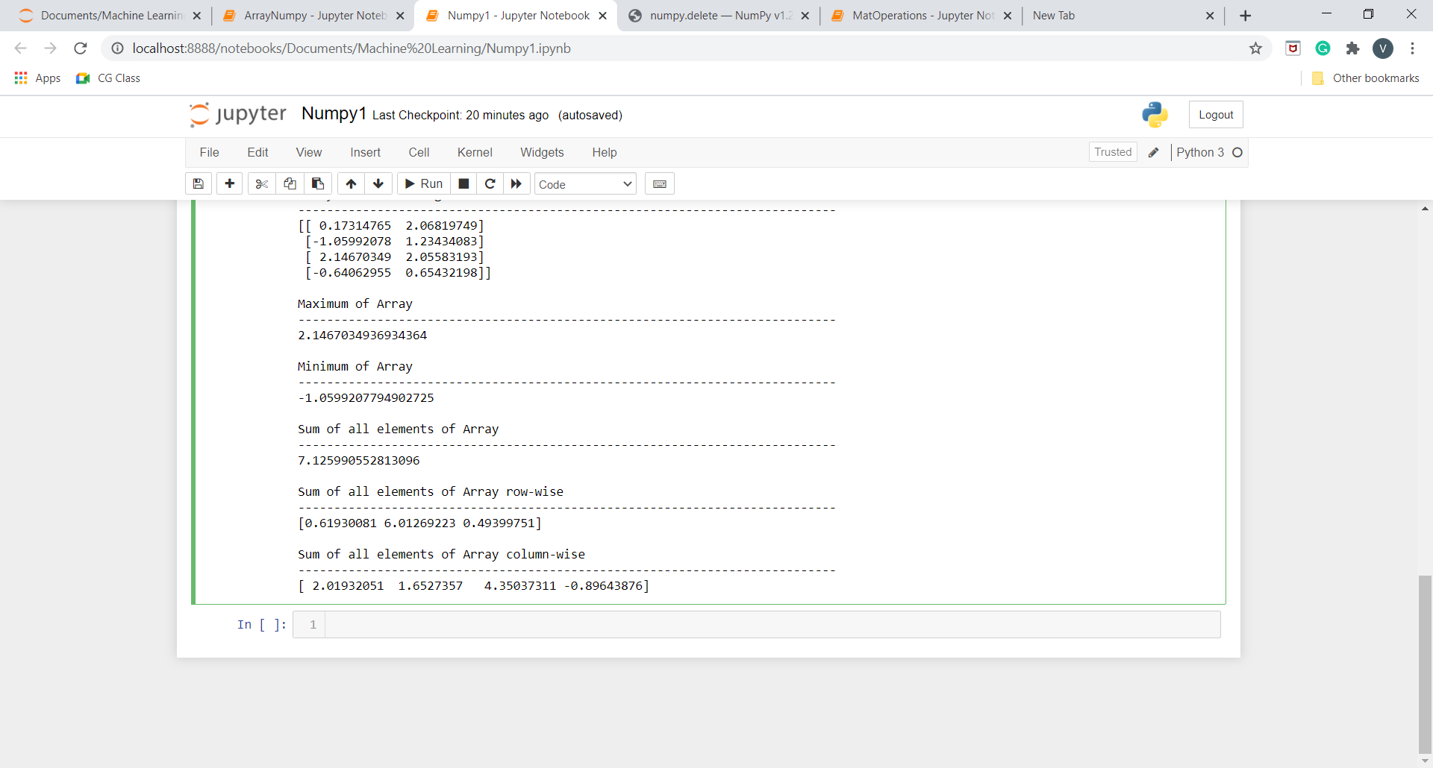

**Q8.Create various type of plots/charts like histograms, plot based on sine/cosine function based on data from a matrix. Further label different axes in a plot and data in a plot.**

**Q9.Generate different subplots from a given plot and color plot data.**

**Program:**

#!/usr/bin/env python

# coding: utf-8

# In[2]:

import matplotlib.pyplot as plt

import numpy as np

# In[15]:

x=np.arange(40)

# In[16]:

x

# In[17]:

plt.plot(x)

plt.show()

# In[18]:

y=np.sin(x)

plt.plot(x)

plt.plot(y)

plt.show()

# In[19]:

y=np.cos(x)

plt.plot(x,color='green')

plt.plot(y)

plt.show()

# In[20]:

x=np.array([1,2,3,4,5])

y=x**2

plt.scatter(x,y,color="orange", label="squares of number", marker="o") #color, label, marker are optional arguments

plt.legend()

plt.xlabel("numbers")

plt.ylabel("squares")

plt.show()

# In[21]:

x=np.array([1,2,3,4,5])

plt.plot(x,x**2,label="squares of number", marker="o")

plt.plot(x,x**3,label="cubes of number", marker="o")

plt.legend()

plt.xlabel("numbers")

plt.title("Squares and Cubes")

plt.show()

# In[22]:

numbers=np.random.randint(0,10,5)

indices=np.arange(5)

indices=indices+2015

numbers2=np.random.randint(0,10,5)

indices2=np.arange(5)

indices2=indices2+2015

print(numbers)

print(numbers2)

# In[23]:

plt.bar(indices,numbers,0.25,color="red",label="rainfall")

plt.bar(indices2+0.25,numbers2,0.25,color="green",label="humidity")

plt.legend()

plt.show()

# In[4]:

labels=["english","hindi","maths","science","social science","computers"]

values=[90,80,40,73,78,43]

plt.pie(values,labels=labels,radius=1)

plt.show()

plt.pie(values,labels=labels,radius=1,explode=(0,0,1,0,0,0),shadow=True)

plt.show()

# In[24]:

u=5

sigma=2

vals=u+sigma*np.random.randn(1000)

print(vals.shape)

plt.hist(vals,50)

plt.show()

# In[26]:

plt.figure(figsize=(8,8))

plt.subplot(221)

plt.plot(x,x**2, label="2018")

plt.plot(x,x**3, label="2017")

plt.subplot(222)

plt.hist(vals,50)

plt.subplot(223)

plt.pie(values,labels=labels,radius=1)

plt.subplot(224)

plt.pie(values,labels=labels,radius=1,explode=(0,0,1,1,0,1),shadow=True)

plt.show()

# In[ ]:

**Output:**

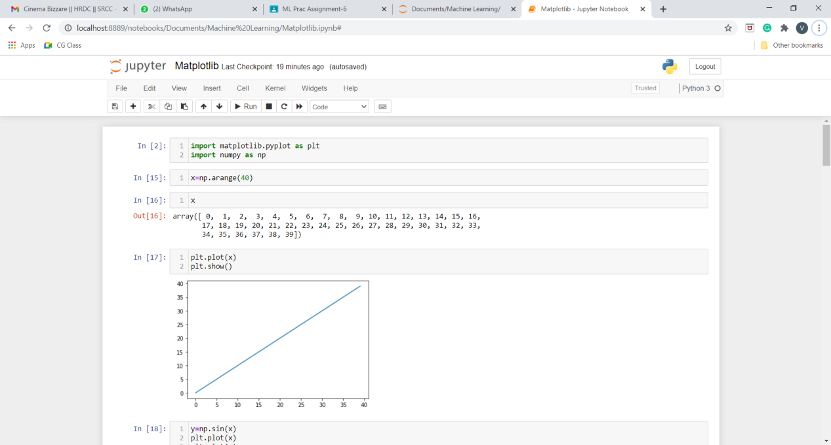

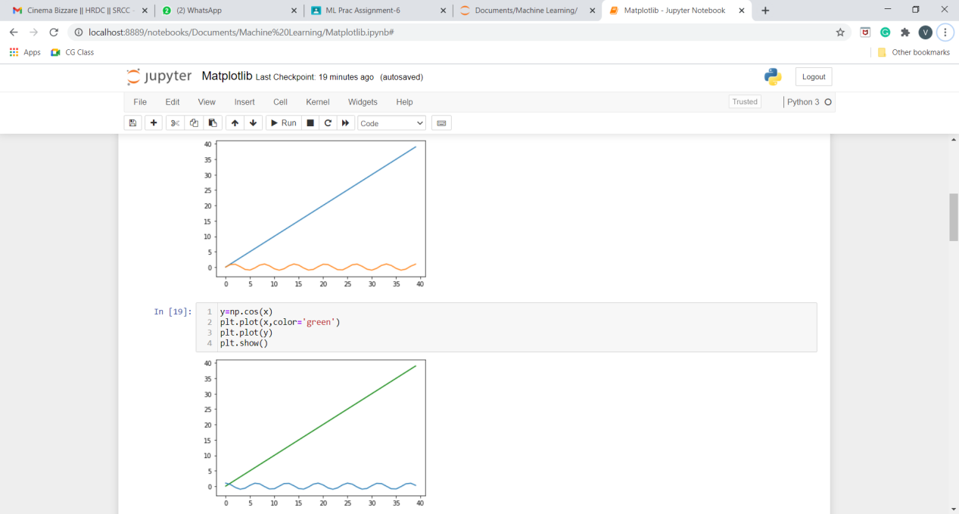

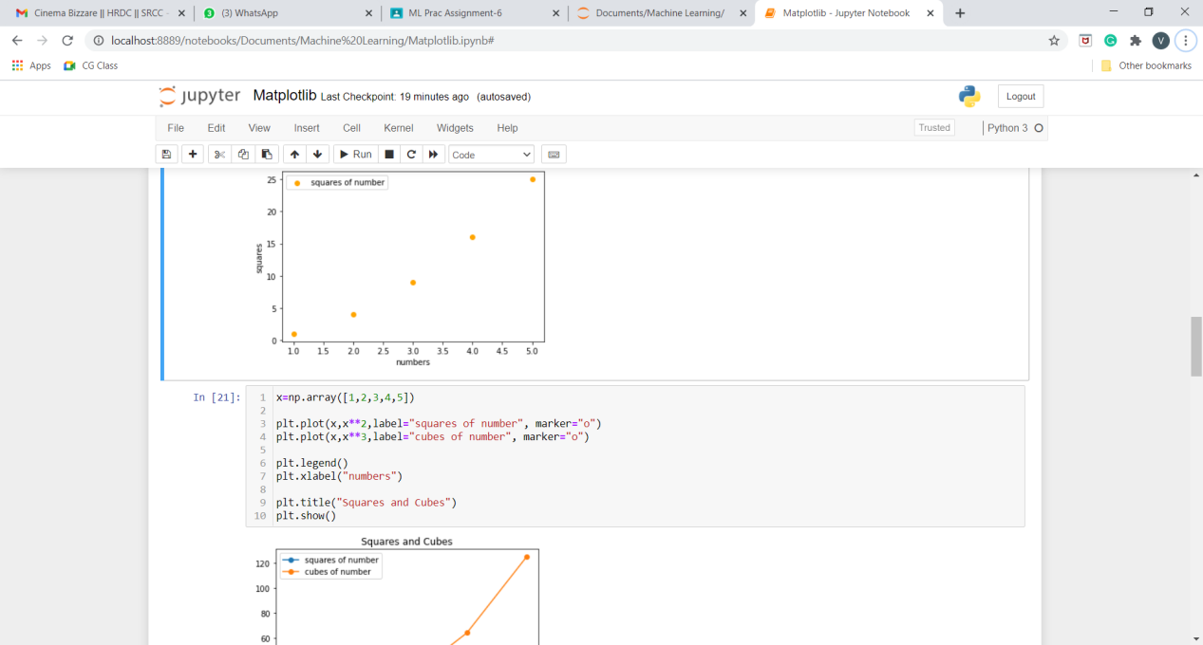

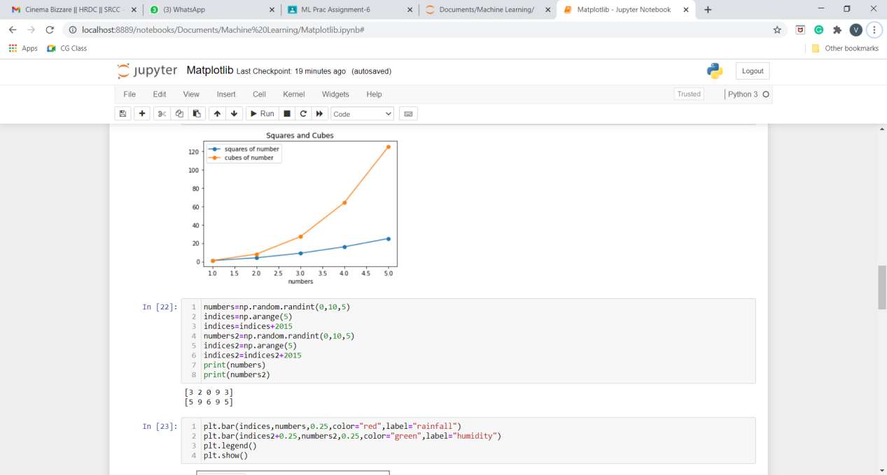

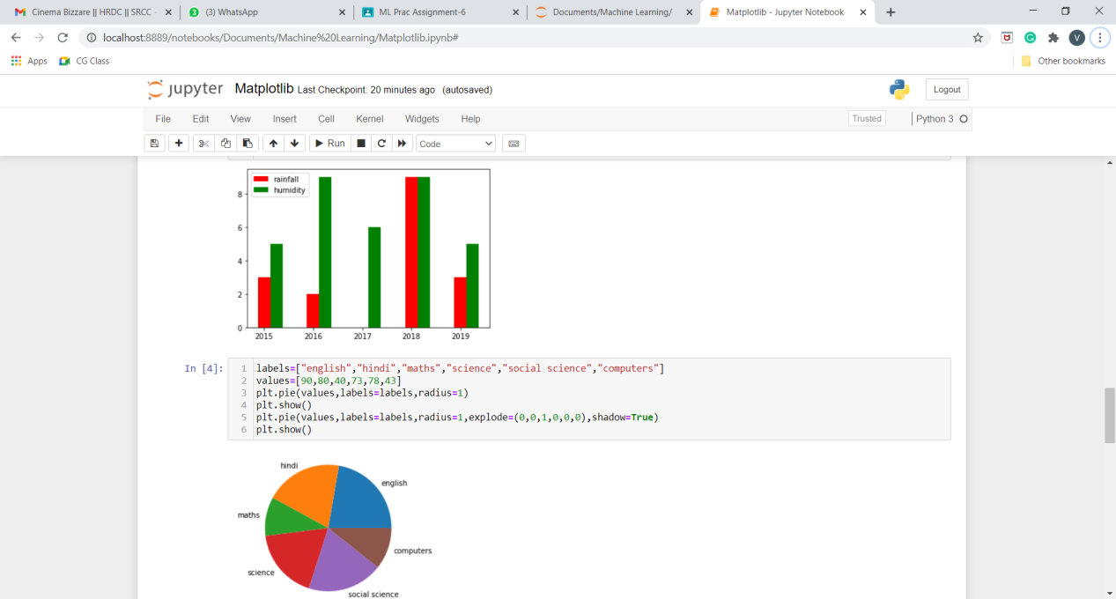

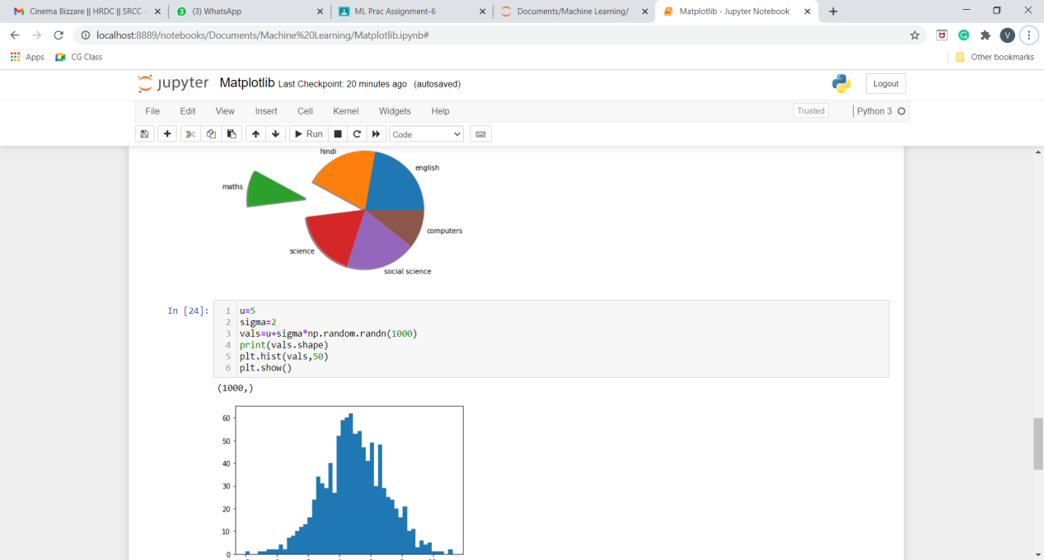

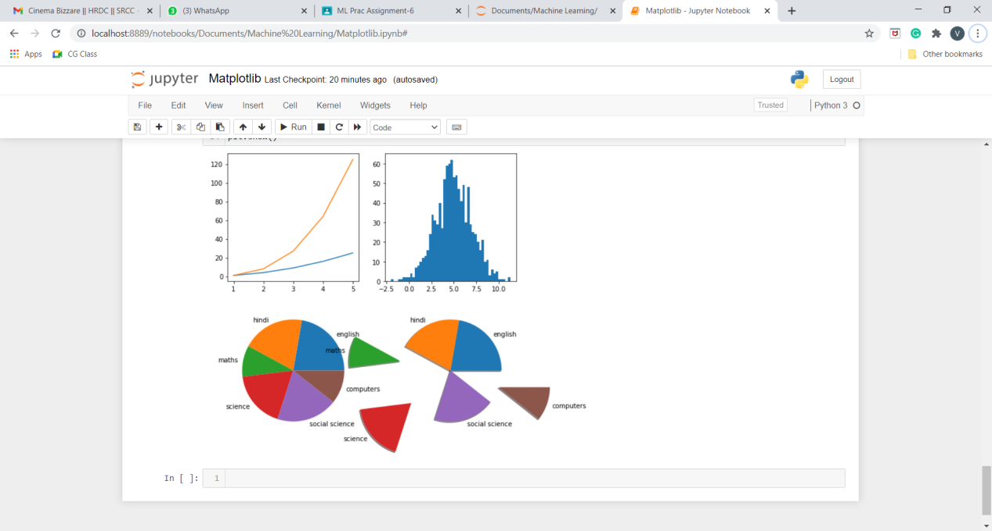

**Q10.Use conditional statements and different type of loops based on simple example/s. (Perform matrix multiplication using nested loops)**

**Program:**

A = [[1, 2, 3],

[4, 5, 6],

[7, 8, 9]]

B = [[10, 11, 12, 13],

[14, 15, 16, 17],

[18, 19, 20, 21]]

result = [[0, 0, 0, 0],

[0, 0, 0, 0],

[0, 0, 0, 0]]

for i in range(len(A)):

for j in range(len(B[0])):

for k in range(len(B)):

result[i][j] += A[i][k] * B[k][j]

for i in range(len(result)):

for j in range(len(result[0])):

print(result[i][j],end=" ")

print()

**Output:**

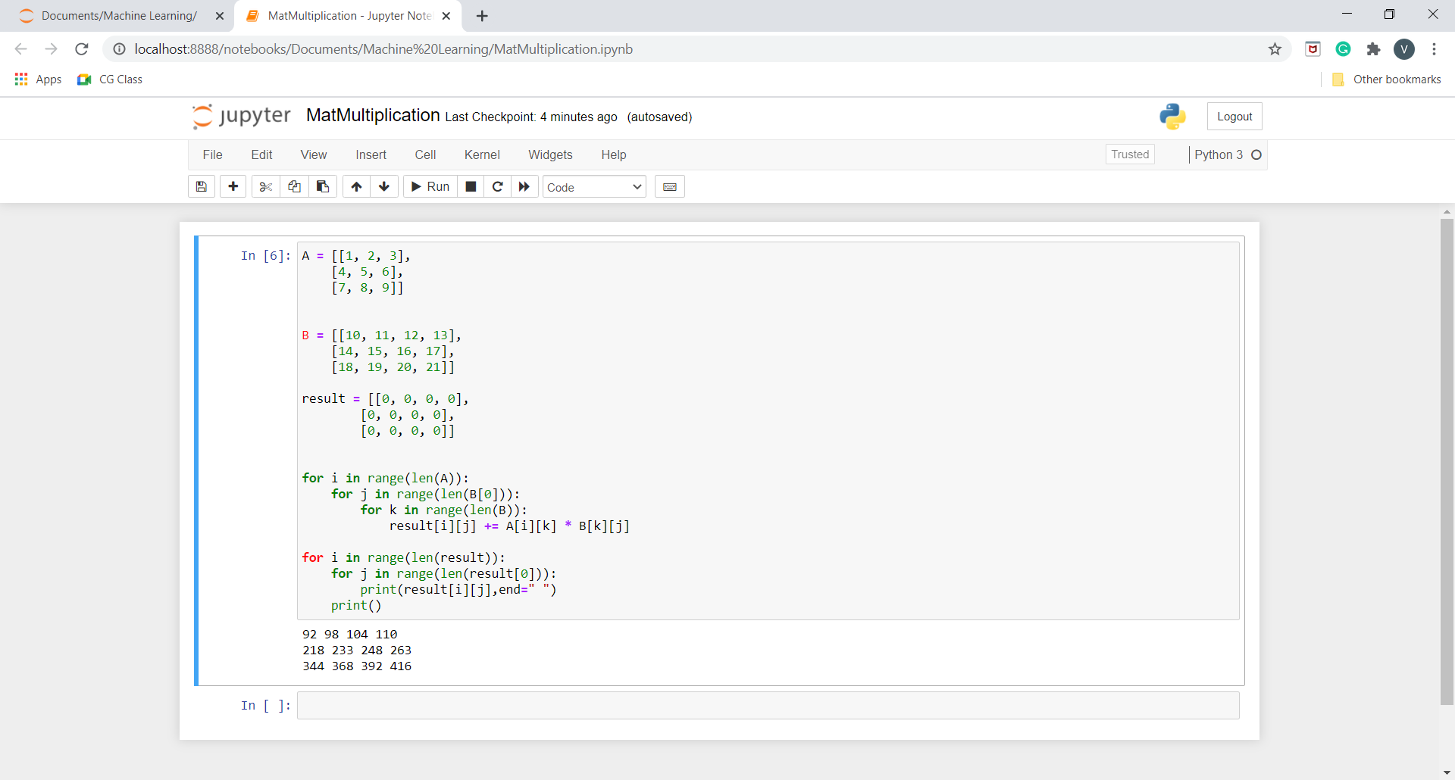

**Q11.Perform vectorized implementation of simple matrix operation like finding the transpose of a matrix, adding, subtracting or multiplying two matrices.**

**Program:**

1. **Plotting of Data:**

**Commands:**

>>> import matplotlib.pyplot as plt

>>> plt.plot([1,2,3],[4,5,6])

[<matplotlib.lines.Line2D object at 0x00000224330A0790>]

>>> plt.draw()

>>> plt.show()

**Output:**

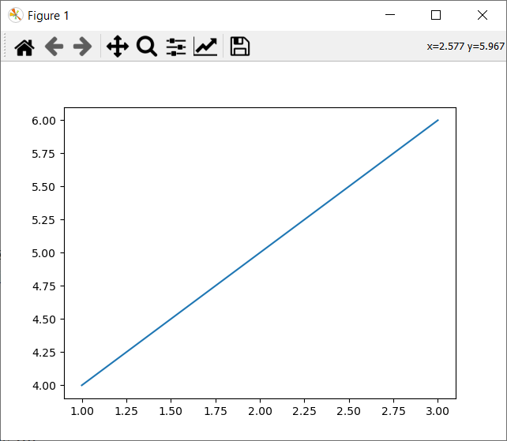

1. **Vectorization:**

**Commands:**

>>> import numpy as np

>>> #converting a tuple into a vector

>>> #using numpy methods to convert into a array

>>> #1-D array

>>> type((1,2,3,4,5))

<class 'tuple'>

>>> x=np.array((1,2,3,4,5))

>>> x

array([1, 2, 3, 4, 5])

>>> type(x)

<class 'numpy.ndarray'>

>>> #2-D array

>>> y=np.random.randn(3,4)

>>> y

array([[ 0.73970731, -0.11279598, 0.26243823, -0.77851299],

[-0.53945554, -0.95227891, -0.41367667, 0.08030448],

[-0.83408442, -0.99784631, -1.91956168, 1.04841069]])

>>> type(y)

<class 'numpy.ndarray'>

>>> #2-D array -->matrices

>>>

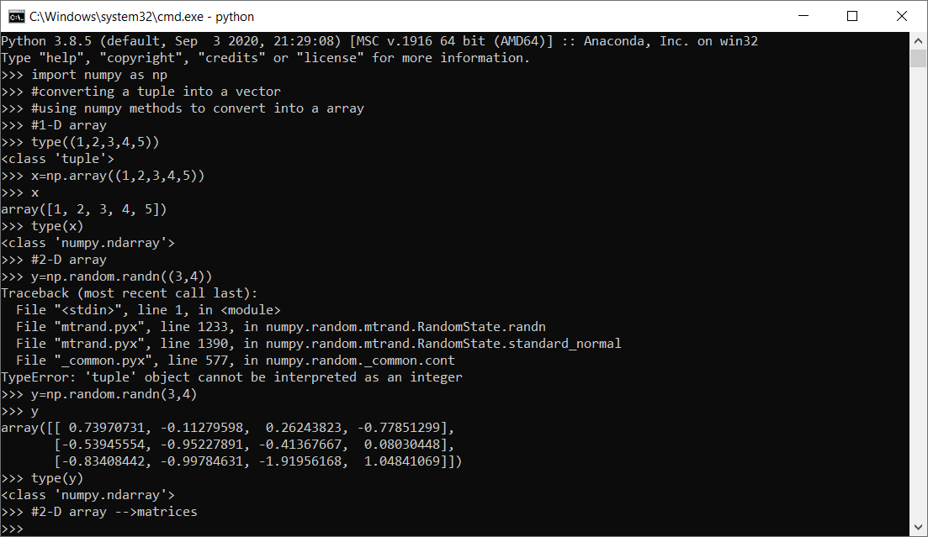

1. **Operations on Vectors:**

**Commands:**

>>> import numpy as np

>>> x=np.array([1,2,3])

>>> y=np.array([9,8,7])

>>> #addition

>>> x+y

array([10, 10, 10])

>>> #subtraction

>>> y-x

array([8, 6, 4])

>>> #product

>>> x*y

array([ 9, 16, 21])

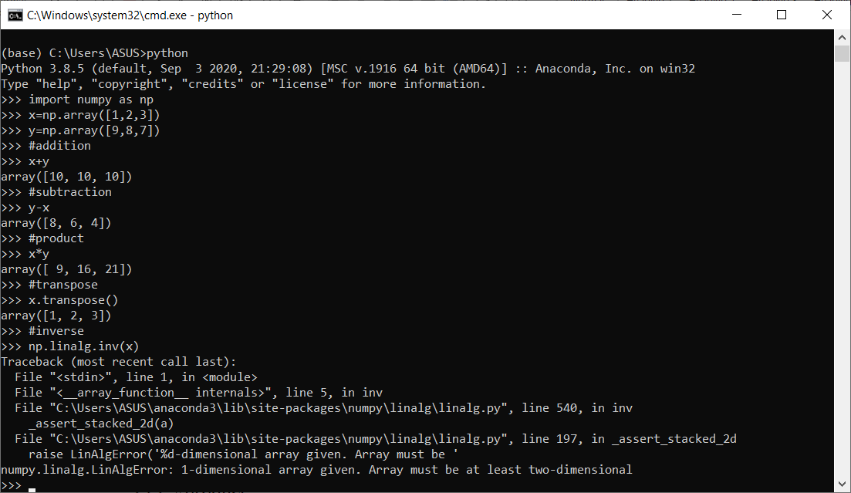

1. **Operations on matrices**

>>> mat1=np.random.randint(1,10,(3,3))

>>> mat2=np.random.randint(1,10,(3,3))

>>> mat1

array([[6, 3, 8],

[3, 4, 5],

[9, 3, 6]])

>>> mat2

array([[3, 7, 6],

[6, 8, 6],

[6, 7, 4]])

>>> #addition

>>> mat1+mat2

array([[ 9, 10, 14],

[ 9, 12, 11],

[15, 10, 10]])

>>> #subtration

>>> mat1-mat2

array([[ 3, -4, 2],

[-3, -4, -1],

[ 3, -4, 2]])

>>> #product

>>> mat1*mat2

array([[18, 21, 48],

[18, 32, 30],

[54, 21, 24]])

>>> #matrix multipliaction

>>> mat1.dot(mat2)

array([[ 84, 122, 86],

[ 63, 88, 62],

[ 81, 129, 96]])

>>> #transpose

>>> np.transpose(mat1)

array([[6, 3, 9],

[3, 4, 3],

[8, 5, 6]])

>>> np.transpose(mat2)

array([[3, 6, 6],

[7, 8, 7],

[6, 6, 4]])

>>> #inverse

>>> np.linalg.inv(mat1)

array([[-0.11111111, -0.07407407, 0.20987654],

[-0.33333333, 0.44444444, 0.07407407],

[ 0.33333333, -0.11111111, -0.18518519]])

>>> np.linalg.inv(mat2)

array([[-0.55555556, 0.77777778, -0.33333333],

[ 0.66666667, -1.33333333, 1. ],

[-0.33333333, 1.16666667, -1. ]])

>>>

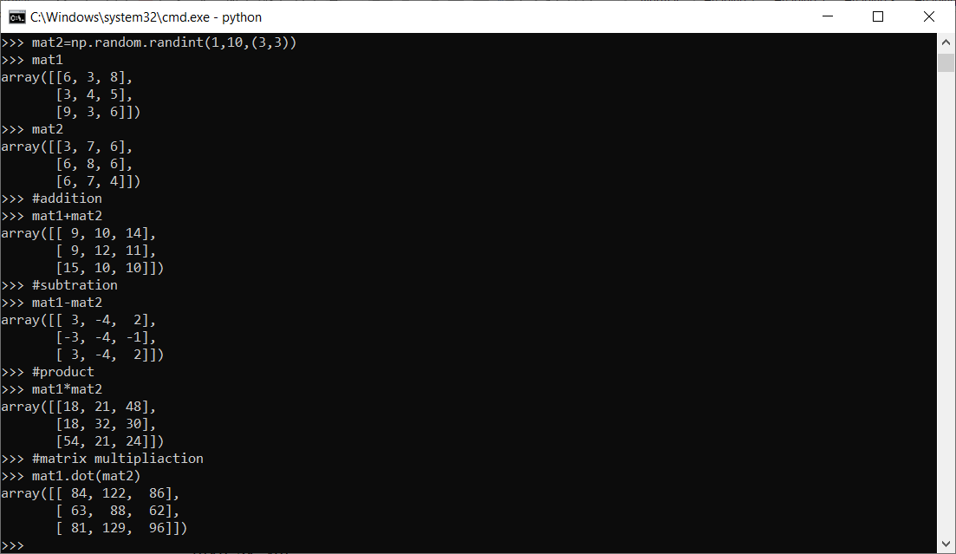

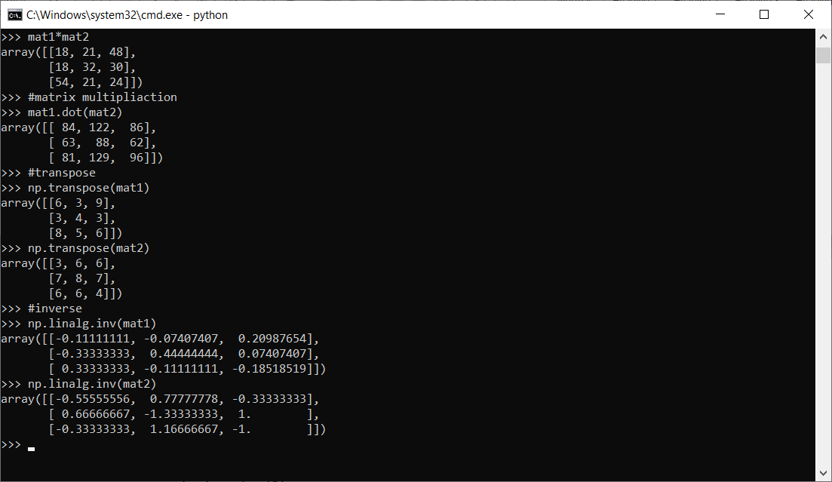

**Q12.Implement Simple Linear Regression on Advertising.csv.**

**Hint : Use functions from sklearn.linear_model, statsmodels.api**

**Program:**

#!/usr/bin/env python

# coding: utf-8

# In[2]:

import pandas as pd

import numpy as np

import matplotlib.pyplot as plt

from sklearn.linear_model import LinearRegression

from sklearn.metrics import r2_score

import statsmodels.api as sm

# In[3]:

data = pd.read_csv(r"Advertising.csv")

data

data.columns

# In[18]:

plt.figure(figsize=(16, 8))

plt.scatter(

data['TV'],

data['sales']

)

plt.xlabel("TV ")

plt.ylabel("Sales ")

plt.show()

# In[19]:

X = data['TV'].values.reshape(-1,1)

y = data['sales'].values.reshape(-1,1)

from sklearn.model_selection import train_test_split

X_train, X_test, y_train, y_test = train_test_split(X,y,test_size=0.3,random_state=0)

print(X_train.shape)

print(X_test.shape)

print(y_train.shape)

print(y_test.shape)

reg = LinearRegression()

reg.fit(X_train, y_train)

# In[20]:

print(reg.coef_[0][0])

print(reg.intercept_[0])

print("The linear model is: Y = {:.5} + {:.5}X".format(reg.intercept_[0], reg.coef_[0][0]))

# In[24]:

predictions = reg.predict(X_test)

plt.figure(figsize=(16, 8))

plt.scatter(

data['TV'],

data['sales']

)

plt.plot(

X_test,

predictions,

linewidth=2,

color='red'

)

plt.xlabel("TV ")

plt.ylabel("Sales ")

plt.show()

# In[13]:

X=X_train

y=y_train

X2 = sm.add_constant(X)

est = sm.OLS(y, X2)

est2 = est.fit()

print(est2.summary())

# In[14]:

print('Train Score :', reg.score(X_train,y_train))

print('Test Score:', reg.score(X_test,y_test))

# In[15]:

from sklearn import metrics

print('MSE :', metrics.mean_squared_error(y_test,predictions))

print('RMSE :', np.sqrt(metrics.mean_squared_error(y_test,predictions)))

# In[ ]:

**Output:**

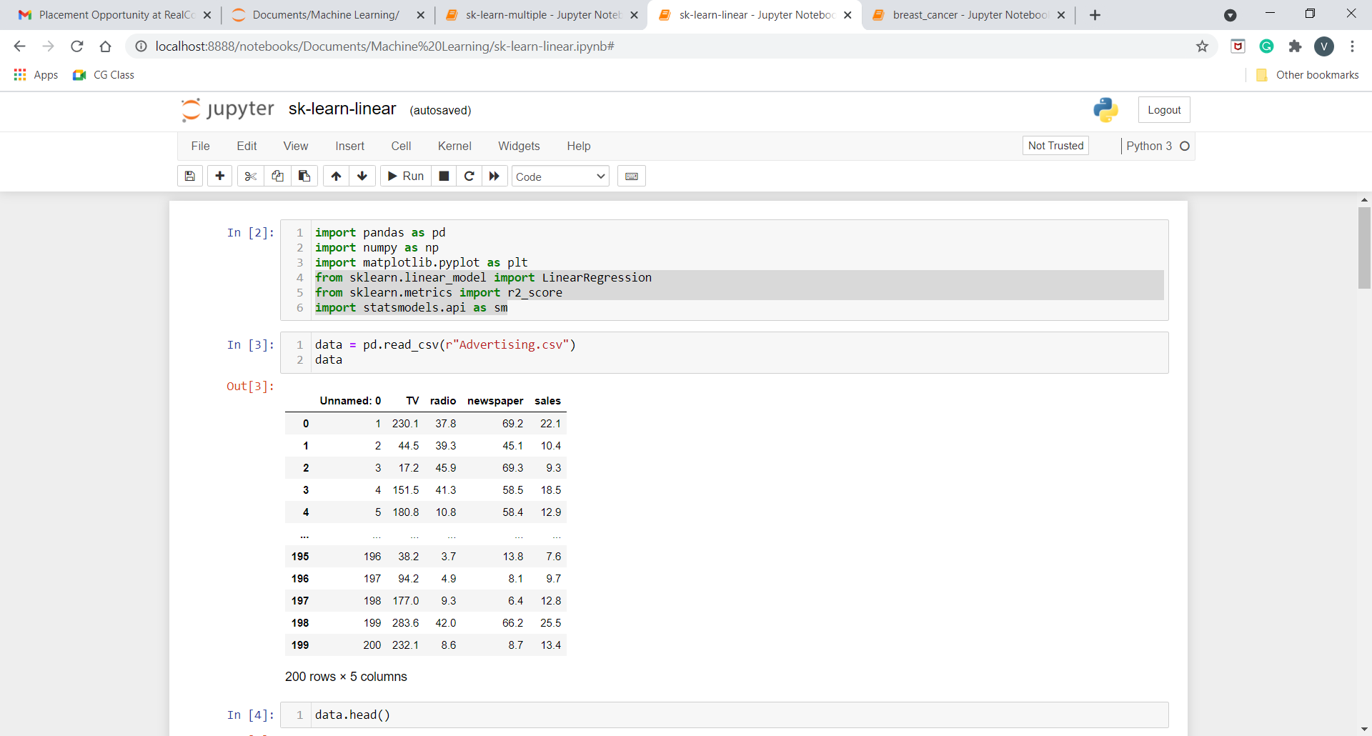

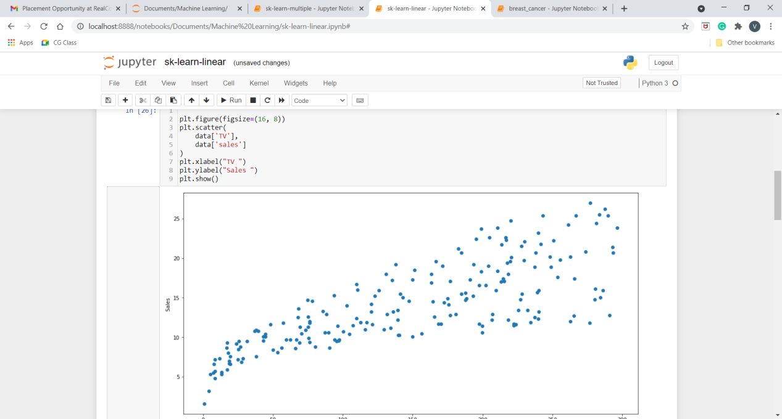

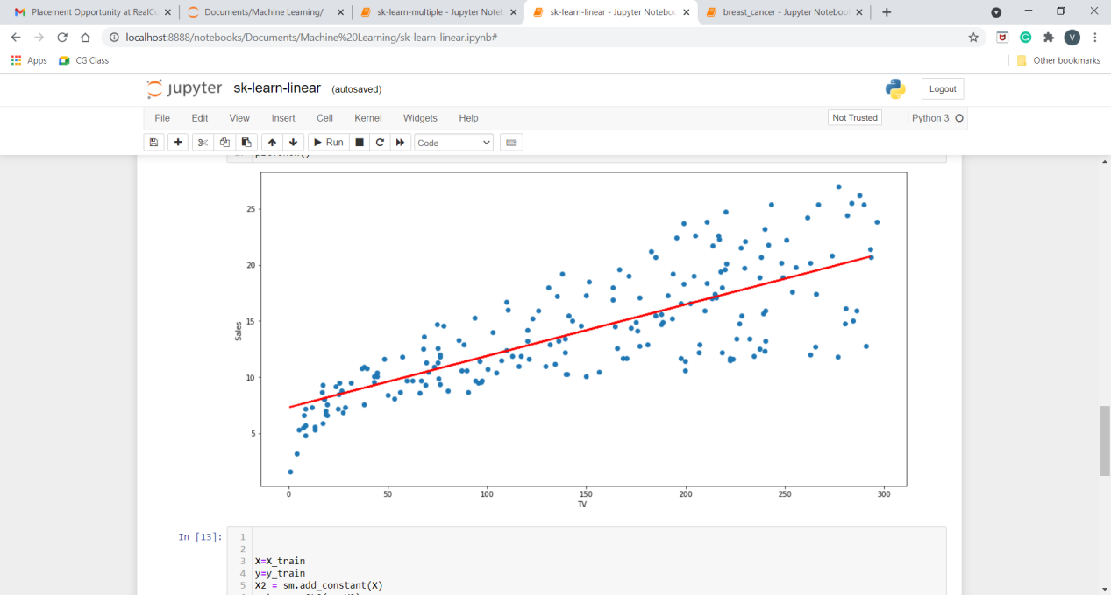

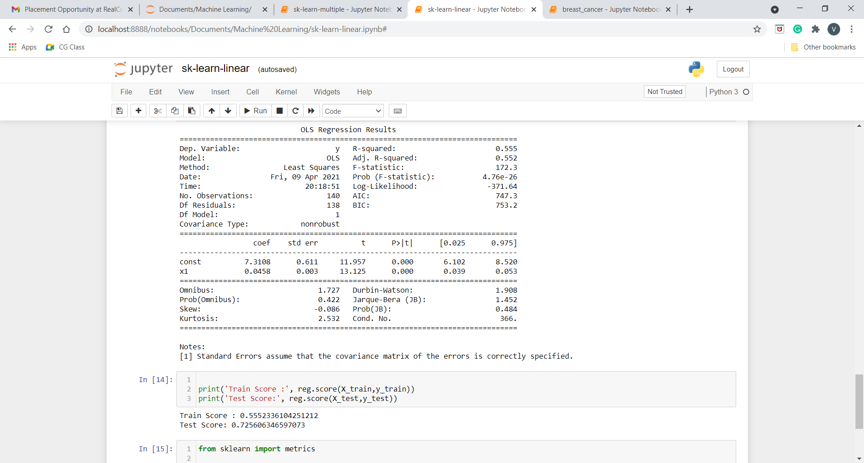

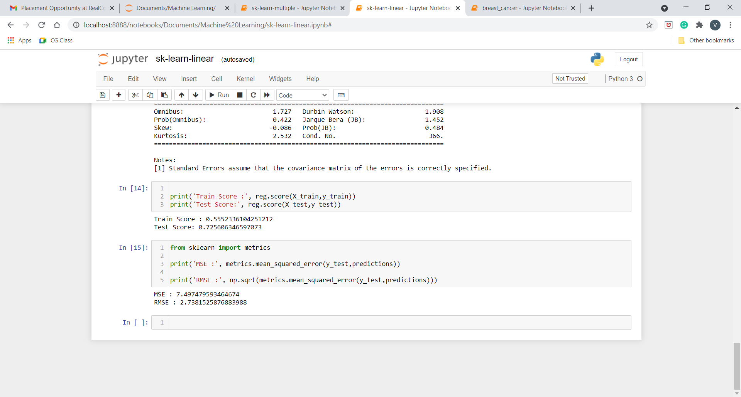

**Q13. Implement Multiple Linear Regression on Advertising.csv.**

**Hint : Use functions from sklearn.linear_model, statsmodels.api**

**Program:**

#!/usr/bin/env python

# coding: utf-8

# In[2]:

import pandas as pd

import numpy as np

import matplotlib.pyplot as plt

from sklearn.linear_model import LinearRegression

from sklearn.metrics import r2_score

import statsmodels.api as sm

# In[6]:

data = pd.read_csv(r"Advertising.csv")

# In[7]:

Xs = data.drop(['sales', 'Unnamed: 0'], axis=1)

y = data['sales'].values.reshape(-1,1)

reg = LinearRegression()

reg.fit(Xs, y)

print("The linear model is: Y = {:.5} + {:.5}*TV + {:.5}*radio + {:.5}*newspaper".format(reg.intercept_[0], reg.coef_[0][0], reg.coef_[0][1], reg.coef_[0][2]))

# In[8]:

X = np.column_stack((data['TV'], data['radio'], data['newspaper']))

y = data['sales']

X2 = sm.add_constant(X)

est = sm.OLS(y, X2)

est2 = est.fit()

print(est2.summary())

**Output:**

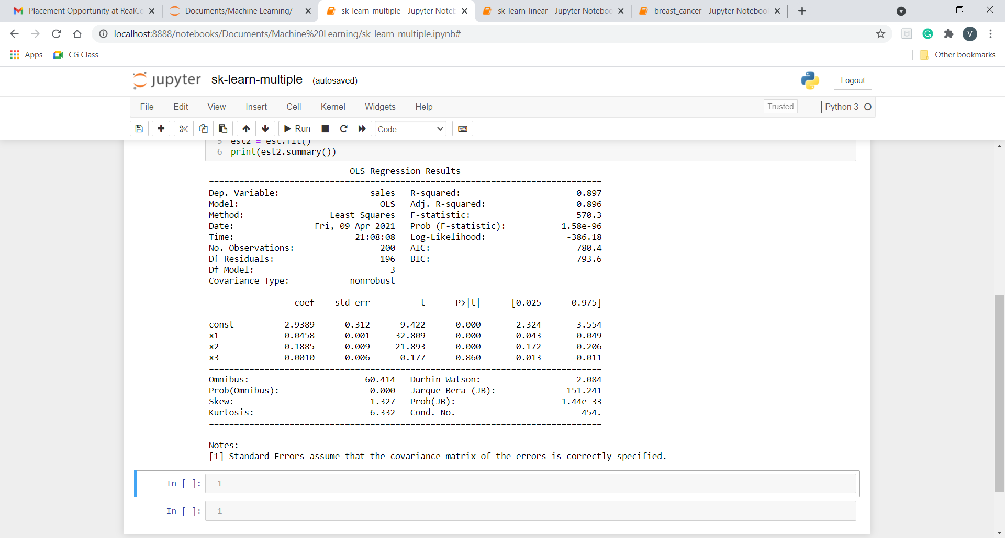

**Q14.Implement Logistic Regression on built in dataset breast_cancer from sklearn.datasets.**

**Program:**

#!/usr/bin/env python

# coding: utf-8

# In[45]:

import pandas as pd

from matplotlib import pyplot as plt

from sklearn.datasets import load_breast_cancer

# In[46]:

df = load_breast_cancer()

#df

# In[47]:

from sklearn.model_selection import train_test_split

# In[48]:

#X_train, X_test, y_train, y_test = train_test_split(df[['age']],df.bought_insurance,train_size=0.9)

X_train, X_test, Y_train, Y_test = train_test_split(df.data,df.target,test_size=0.2, stratify=df.target,random_state=42)

# In[49]:

X_test.shape

# In[50]:

Y_test.shape

# In[51]:

from sklearn.linear_model import LogisticRegression

model = LogisticRegression(C=0.1)

# In[53]:

model.fit(X_train, Y_train)

# In[54]:

#X_test

# In[41]:

y_predicted = model.predict(X_test)

# In[42]:

print('Accuracy on the training subset: {:.3f}'.format(model.score(X_train, Y_train)))

print('Accuracy on the test subset: {:.3f}'.format(model.score(X_test, Y_test)))

# In[43]:

#X_test

# In[44]:

from sklearn.metrics import confusion_matrix

confusion_matrix(y_test,y_predicted)

# In[57]:

from sklearn.metrics import plot_confusion_matrix

# In[ ]:

**Output:**

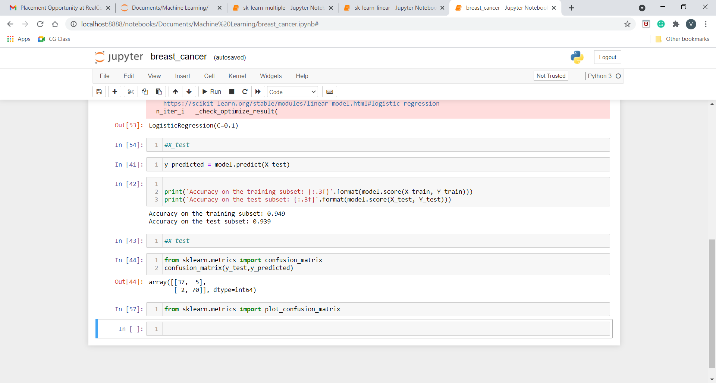

**Q15.Use some function for regularization of dataset based on problem 14.**

**Program:**

#!/usr/bin/env python

# coding: utf-8

# In[1]:

import pandas as pd

from matplotlib import pyplot as plt

get_ipython().run_line_magic('matplotlib', 'inline')

from sklearn.datasets import load_breast_cancer

# In[2]:

df = load_breast_cancer()

#df

# In[3]:

from sklearn.model_selection import train_test_split

# In[4]:

X_train, X_test, y_train, y_test = train_test_split(df.data,df.target,test_size=0.2, stratify=df.target,random_state=42)

# In[5]:

X_test.shape

# In[6]:

from sklearn.linear_model import LogisticRegression

model = LogisticRegression(C=100)

# In[7]:

model.fit(X_train, y_train)

# In[8]:

model.coef_

# In[9]:

from sklearn.linear_model import LogisticRegression

model = LogisticRegression(C=1)

model.fit(X_train, y_train)

model.coef_

# In[10]:

### Coefficent's Value (decrease) if C value (decrease)

### Coefficent's Value (increase) if C value (increase)

# In[11]:

y_predicted = model.predict(X_test)

# In[ ]:

**Output:**

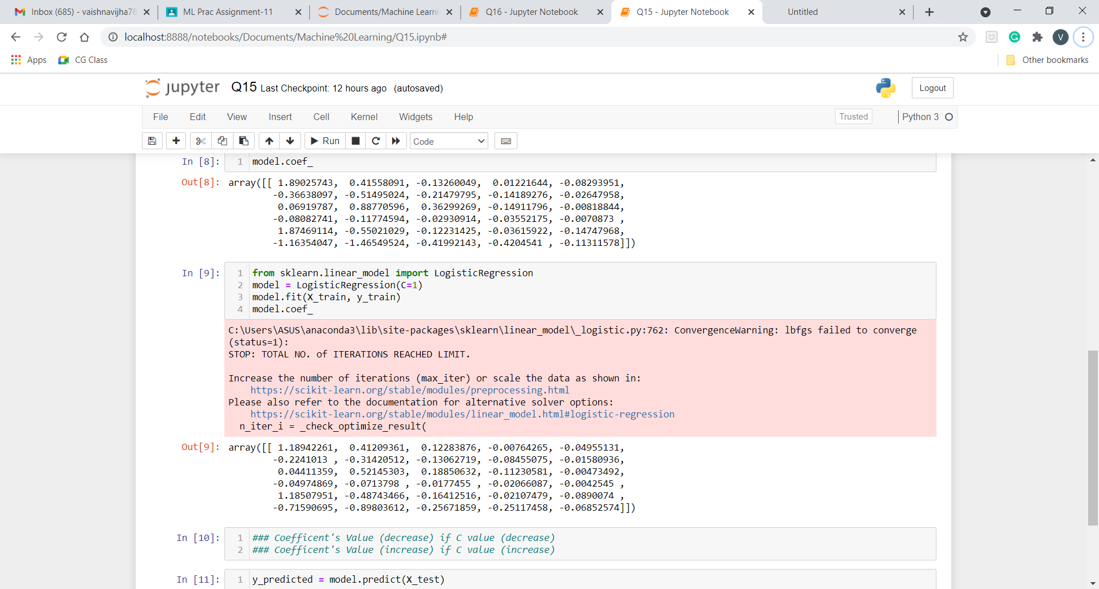

**Q16.Use some function for neural networks, like Stochastic Gradient Descent or backpropagation - algorithm to predict the value of a variable based on the dataset of problem 14.**

**Program:**

#!/usr/bin/env python

# coding: utf-8

# In[1]:

from numpy import*

import pandas as pd

from sklearn.datasets import load_breast_cancer

from sklearn.neural_network import MLPClassifier

from sklearn.model_selection import train_test_split

# In[2]:

df = load_breast_cancer()

# In[3]:

X_train, X_test, y_train, y_test = train_test_split(df.data,df.target,test_size=0.2,random_state=4)

y_test

# In[4]:

nn=MLPClassifier(activation='logistic',solver='sgd',hidden_layer_sizes=(10,15),random_state=1)

# In[5]:

nn.fit(X_train,y_train)

# In[6]:

pred=nn.predict(X_test)

pred

# In[7]:

from sklearn.metrics import accuracy_score

accuracy_score(y_test,pred)

# In[ ]:

**Output:**

